**CSC 110: Lab 0**

**Deadline: 07/ 06/ 2020. 11:59 PM**

**Welcome to the CSC 110 Lab!**

Welcome to another exciting semester of Computer Science! The **CSC 110** lab that you are taking has a goal of kick-starting students in Java by introducing them to the basic syntax and useful/essential features of **Java**.

**For today’s lab, you’ll be practicing the following skills:**

* Install the software for Java
* Creating your First Program in Java by printing a Line of Text.

**Instructor Expectations:** When working through the CSC 110 labs, you will often need to ask me questions and share your screen on Zoom to check over your progress and OK your progress. The labs will include two important parts, the **Lab Instructions and the Tasks to Do.** Please read them carefully.

**Lab Instructions**

1. Lab attendance is **MANDATORY** to enhance the student’s hands-on experience.
2. The Lab will be posted on Canvas in the “Assignments” section. Each lab will include instructions, a due date, and a link for electronic submission.
3. Please submit your lab work before the submission deadline. You can continue to resubmit your files as many times as you would like up until the deadline, so please feel free to upload early and often. If you submit the lab past the deadline, then the assignment will be marked as late.
4. While you are working on the lab, you need to share your screen on Zoom with me to check over your progress and to OK your progress.
5. You must have code that has good style, header comments for each method you write, and full testing.
6. I will inform you what is missing and what needs to be fixed before the final submission. You’ll need to make the necessary changes before calling me back and getting the OK to submit your lab work.

**Tasks to Do:**

1. **Install Software.** First, download and install the following software.

## 1.1 Java SE Development Kit 8

The Java Standard Edition (SE) Development Kit (or JDK for short) provides the ability to run programs written in Java (including applets in a browser), as well as compile new programs. By contrast, the Java Runtime Environment (JRE) can run programs, but not to make new ones.

We will use the latest version of the Oracle JDK, version 8 (you will see JDK8 as well as 1.8, which mean the same thing). Use the search term “jdk8” to find Oracle’s download page. Then, download and install the latest “update” (e.g. 8u101) for your platform (use 64-bit unless you have a particular reason not to).

Java is widely used, and thus it is common for vulnerabilities to be discovered/exploited in the JDK. You should keep your version up to date in order to limit your exposure.

## 1. 2 Eclipse IDE for Java Developers

There are several good integrated-development environments (IDEs) for Java (e.g. NetBeans, IntelliJ) – in this class we will use Eclipse. Eclipse has a highly extensible plug-in system, supports many languages/platforms (e.g. Android), and is widely used in industry.

First, navigate to the Eclipse Downloads page (search term “eclipse java download”) – click “Download Packages” from there. Next, download “Eclipse IDE for Java Developers” for your platform (match 32/64-bit to the JDK version above). Eclipse typically comes as a compressed folder – you can extract the contents wherever is convenient and simply run the main eclipse executable (e.g. eclipse.exe on Windows, Eclipse.app on Mac OS). There is a new installer option, which still seems to be buggy/slow.

When you first run Eclipse, it will ask you to indicate a “workspace” – this is a folder that will house all of your projects. You should choose a folder that does not currently exist, as Eclipse will directly manage its contents. After this, click the “x” icon, closing the “Welcome” tab (see the screenshot below) – you are now ready to use Eclipse.

1. If you plan to use your own laptop, create a folder called CSC 110 somewhere on your computer. This is where you will keep all of the labs and homework assignments for this class.
2. Change the **Welcome1.java** program so that it displays **Hola ..Your Name!**
3. Write a program that displays the following pattern:

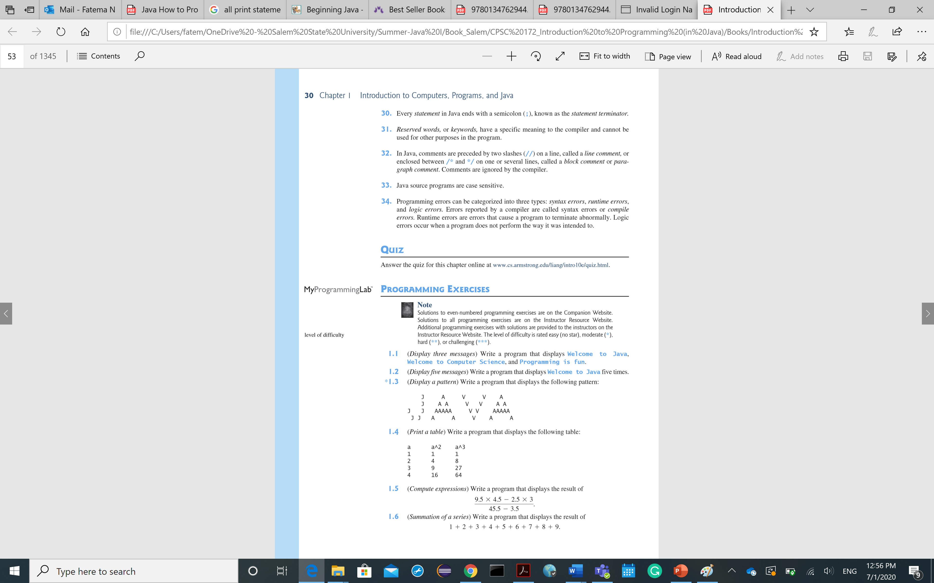

1. You will be submitting the folder eclipse created for you. Rename folder **labXX firstName_lastName** where “XX” is the number of the lab (“1”, “2”, “3”, etc.). To rename a folder on a Windows machine, right-click and choose “Rename”. To rename a folder on a Mac machine, click on the folder and hit the enter key.
2. **Zip the folder**. After you have renamed your folder, right-click on the folder and select “Send to > Zip file” (on Windows) or “Compress” (on Macs). This will generate a zipped (.zip) file.
3. **Upload zipped** file into Canvas.
4. Now, **submit** the code to the instructor via Canvas.

*Good job, you’ve completed your first lab!*